The Dark Web Method
How to safely use and understand the Dark Web
By Szymon Stefański

Disclaimer
Please note, that this research is for educational purposes as a part of my learning path in cybersecurity and networking. I do not encourage anyone to use the dark web for illegal activities or promote them. I explain how to safely use it and explore it efficiently, but on your own accountability for your actions. Suggested tools and rules are based on my personal opinion, so keep that in mind during reading and/or usage.

Table of Context
The Dark Web Method 1
Disclaimer 1
Introduction 3
Section one: Dark Web in a nutshell 4
Quick Introduction 4
What is the Dark Web? 4
Architecture and Communication 4
How to NOT get Lost or Hacked 5
Rules of safety: 5
Exploring the Dark Web 6
Section two: The Dark Web Method 7
Quick Introduction 7
Tails Linux 7
Whonix linux 8
Tails vs whonix 10
Tor Browser 11
Robin 11
Summary of Research 15
Reference 15

Introduction
This project is a part of my personal education path into the world of cybersecurity and networking. During this research document I will present my work, thoughts and conclusions on how to actually use the dark web safely. I divided this project into two sections: Dark Web in a nutshell and The Dark Web Method.
In the first section I will explain what the dark web is, how communication works there and how the dark web is built from an architecture perspective as a network. I will also provide some tips and rules on how to use it in a reasonable way.
In the second section I will proceed with the main subject - How to set up an environment that will allow anyone to search the dark web safely without fear or getting lost.
However please keep in mind, those are my personal opinions and it's all part of my education project. Abuse of the information for illegal purposes is forbidden and dangerous. Treat this document as a reminder that the dark web can be used efficiently and for a good purpose, but do not forget it's an unforgiving place.

Section one: Dark Web in a nutshell

Quick Introduction
In this section I’ll present how the dark web is structured as a network, how communication happens and what actually is the dark web. I will include some rules, additional information and thoughts on how to search the dark web safely.

What is the Dark Web?
The dark web is a hidden part of the Internet with a different way of entering and moving around than what we use every day. It gives strong privacy and keeps users out of sight, which can be helpful but also misused. Because of this privacy, it is often linked with criminals or secret groups, but it is also used by journalists, people who lack open Internet access, and those who work to keep the online world safer.

Architecture and Communication
The dark web is called “dark” not because of crime, but because it works like a quiet room with no light. You step inside and see nothing. You don’t know where anyone or anything is because everything is hidden.
The structure is simple to imagine. It works as a network of “onions.” Each relay is like an onion with many layers, and every layer adds protection in the form of additional encryption. Instead of normal web addresses, every page has a long, random string of letters and numbers ending with .onion, meaning that there is no standard DNS server that helps during searching.
That's why communication works differently here. Each relay is a device that helps pass traffic along the path. When you look for a page, you ask one relay, and if it doesn’t know the way, it asks the next one. Neither side knows who or where the other is, because that information is never shared. This whole part is only the lookup phase, similar to finding a name in a phone book, linked to something called a Distributed Hash Table ( DHT ).

How to NOT get Lost or Hacked
You ask yourself a question : “I can’t see anything, I don’t know where anything or anyone is, how do I find something at all?”. Normally, you can’t find anything unless you already know the page address. To make it even harder, some pages are active only on specific days of the week and completely randomly, making it harder to find them. Other pages change the address after some time. Furthermore there are multiple honeypots left by criminals and secret groups, fake pages, or places filled with as many malicious scripts and programs as possible. That's why I suggest you comply with rules of safety.

Rules of safety:

- Never click on any suspicious looking pages or ads.
- Always check everything you see and think carefully beforehand - some sites recommend verifying the web page address or to check encryption key.
- Never just go straight to the dark web - it's better to equip yourself with tools to make you safer, like Tor, VPNs, isolated environments ( e.g Virtual Machines ) and more.
- Try to always change your behaviour - never look too many times on the same browsing session, change your IP every few searches, try to leave as few fingerprints as you can - There are ways to take advantage of your activity to build your profile, that will help figuring out who you are.
- Approach everything with excessive caution and exaggeration - zero-trust is really important.
- Never share your real information or anything that could potentially endanger you.
- Monitor your environment for any suspicious changes.
- Try to verify services you want to use if possible to check authenticity.

Exploring the Dark Web
There are places online that collect lists of dark web sites, often called dark Wikipedias. These lists can be helpful, but many links are outdated or no longer active, so it’s common to find very little that still works.
A researcher, Mr. Apurv Singh Gautam, created an open‑source AI tool called Robin. It scrapes dark web pages and gathers information such as summaries, links, suggestions, insights and basic notes. It also stores simple .json files so you can look back at what it found. This tool is part of my research on how people move around this space.

Section two: The Dark Web Method

Quick Introduction
This section presents the core of the research. I describe the tools and methods that can make looking into the dark web more structured and safer to explore.

Tails Linux
Tails is a linux distribution focused on leaving as little evidence of usage as possible. Its whole idea is simple to imagine, like a goldfish, it forgets everything that was ever done inside of it, including downloads, updates, search history, interactions, passwords - everything. It is very popular to use the inside of a USB stick which makes it even more convenient. Each time after shutdown it resets, because it works entirely on RAM, making it a short time memory linux distro. On top of that it includes very rigoristic safety measurements to leave little to no digital footprint.
However there is a special mechanic named persistent storage, which is a folder where downloads and files can be saved and will survive shutdown ( this uses the USB stick storage ). Tails comes with a pre-installed Tor browser and Tor circuit.
From my experience Tails is fun to use, leaves no virtual traces of usage as long as you plug it out, gives you full privacy, however it is very slow, limited to RAM space and persistent storage is restricted as well. During my experiments I tried to install packages for tools ( docker, robin, python ) to make searching the dark web easier, but the built- in security measurements and the main functionality itself made it impossible to do so. It's good to use for quick searches, or when you want to find something on a public computer and leave no traces. Unfortunately it’s not very efficient or tool friendly, so I continued to look for other alternatives.

Whonix linux
Whonix is a linux distribution, similar to tails, focused on privacy, security and anonymity, but in a different approach. The version of whonix I used was made for virtualbox. In such case whonix is divided into two smaller virtual machines - Whonix gateway and Whonix workstation.
Whonix gateway is the only VM that has access to the physical network card of your computer. It works as a universal filter with Tor, port filtering, firewall, traffic interception and more. It is not the main machine for usage, but it is an extremely important part of security. It also includes tor circuit and special tool called nyx for tor network monitoring.
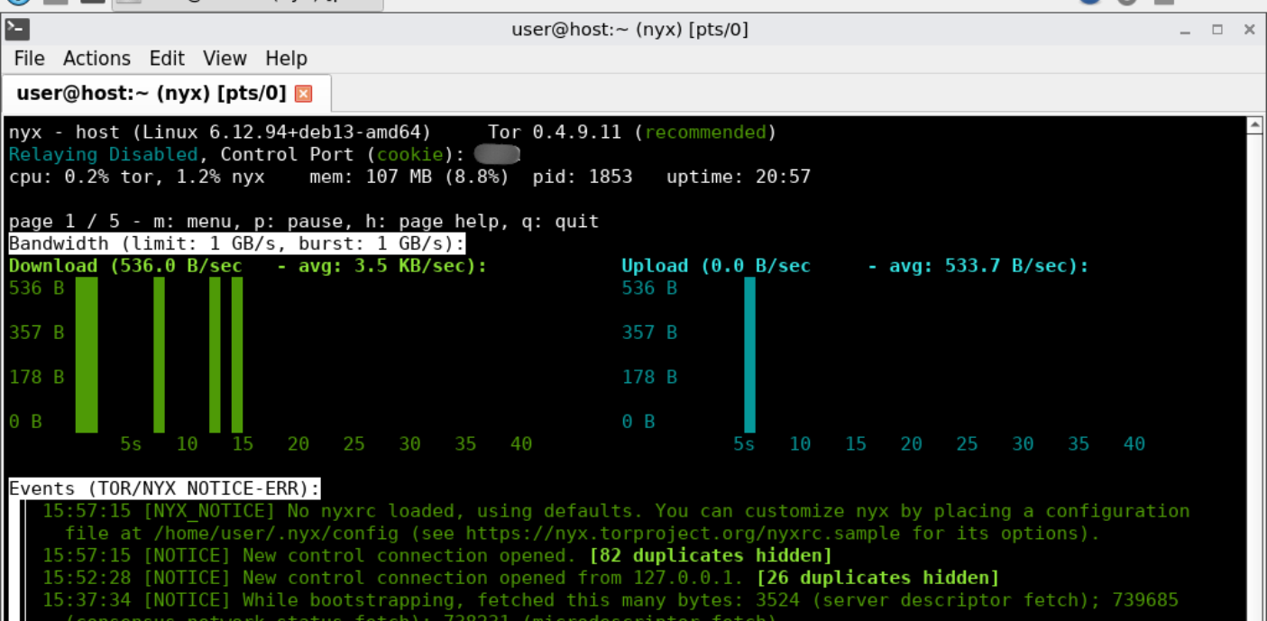
Whonix workstation on the other hand is the main machine in terms of daily usage. It's an isolated container, where users can install tools, code, search dark web and more. However the catch is that every single traffic goes through the gateway. Furthermore, the workstation has no information about the host computer, nor does it have access to it, nor does it have direct access to the router. This way, the workstation is completely isolated and safe, including its own safety measurements as well.
In summary, both machines work together to create a safe, isolated and filtered environment that even if compromised, will not have access to the real IP address or information of the host. They are two additional mechanics that support such statement:
- Stream isolation is part of both VMs' security points. Each port and node are separate circuits to make it harder for an attacker to correlate any activities to build your profile.
- User-sysmaint-split mechanic is another important part. It separates user and super user accounts completely. It means that during normal usage, you’re logged in as a standard user and have no possibility to change to su or use sudo commands, both are immediately denied. Super user is only accessible via maintenance panel in sysmaint session, which can be loaded during boot. This mechanic allows to minimalise risk of privilege escalation of compromised system. However it was also a reason why I didn’t use docker for tool set up. Docker needs kernel level access and root privileges, on whonix it wouldn’t be possible and setting up rootless docker could potentially create a security risk that I didn’t want to include.
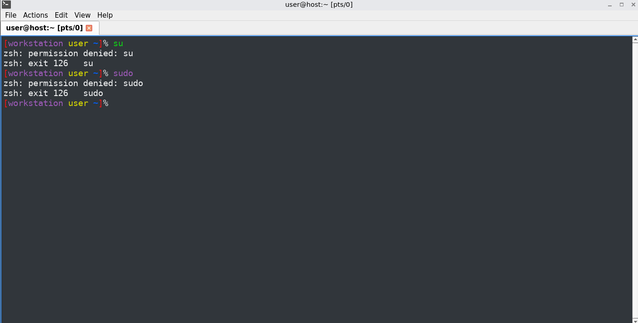

Tails vs whonix

Feature | Tails | Whonix
IP Leak Protection | Firewall rules on one OS | Physical separation of network stack
If OS is Compromised | Attacker might find real IP | Attacker cannot find real IP (trapped in VM)
Development | Broken by design (RAM/Storage) | Native support (Full Debian system)
Stream Isolation | Hard to configure | Configurable per app via Gateway
In short, during my experiment, whonix allowed me to download and use tools in an isolated and safe environment, gateway kept the network traffic safe, stream isolation got rid of any correlation between ports and preinstalled tor tools for both VMs will allow me to enter dark web. Even in the case of a compromised system, the fact that both gateway and workstation are just virtual machines, I could always delete them or restore their previous state from snapshots.

Tor Browser
There are multiple tools and ways to search dark web, and for each one of them the important part is the Tor browser - It's a special browser that supports dark web search, allowing it to find onion sites. It implicates javascript blocking, IP changing, onion site verification and special Tor circuit, which is a path of different relays. The number of nodes ( relays ) differs based on what you search - for standard browsing it uses 3 nodes as below, for onion search that number goes to 6, as the destination itself uses those 3 nodes as well. Keep in mind that this refers to the connection phase, where we know that such a page exists and where its server lies.
- First node ( Guard node ) - It gets the data you want to send, like a request for a page, and knows your IP ( not the real one )
- Middle node(s) - It is entirely blind, it only moves data from first node to exit node
- Exit node - It knows your destination, but it doesn’t know your IP
As the creators of Tor state, increasing the number of relays would make searching much harder, because it would just increase load on the network and potentially make it easier to make DOS attacks. Shorter paths, like for example 2 are also more dangerous, because then both nodes know each other, meaning it's easier for the attacker to find out which relay to attack to find the user's identity.

Robin
As mentioned, Robin is an open-source AI tool that scraps dark web’s pages to find the safest, verified, real websites. It is based on the model of your choice, that you need to set up using API keys. Robin can be set up in two ways : Via docker or python
I chose the development version via python - why? Because docker needs access to Kernel and root privileges to create its environments and on both whonix and tails I used for this experiment it was causing security errors or would create a vulnerability gap inside the system.
Python also allows the creation of an additional project environment using venv, which separates all project packages from the system ones. I do it, as there was an issue with externally-managed-environment error that is due to pip install command, which is blocked on some OS, including whonix and tails, to prevent pip from accidentally overwriting or breaking critical Python packages globally.
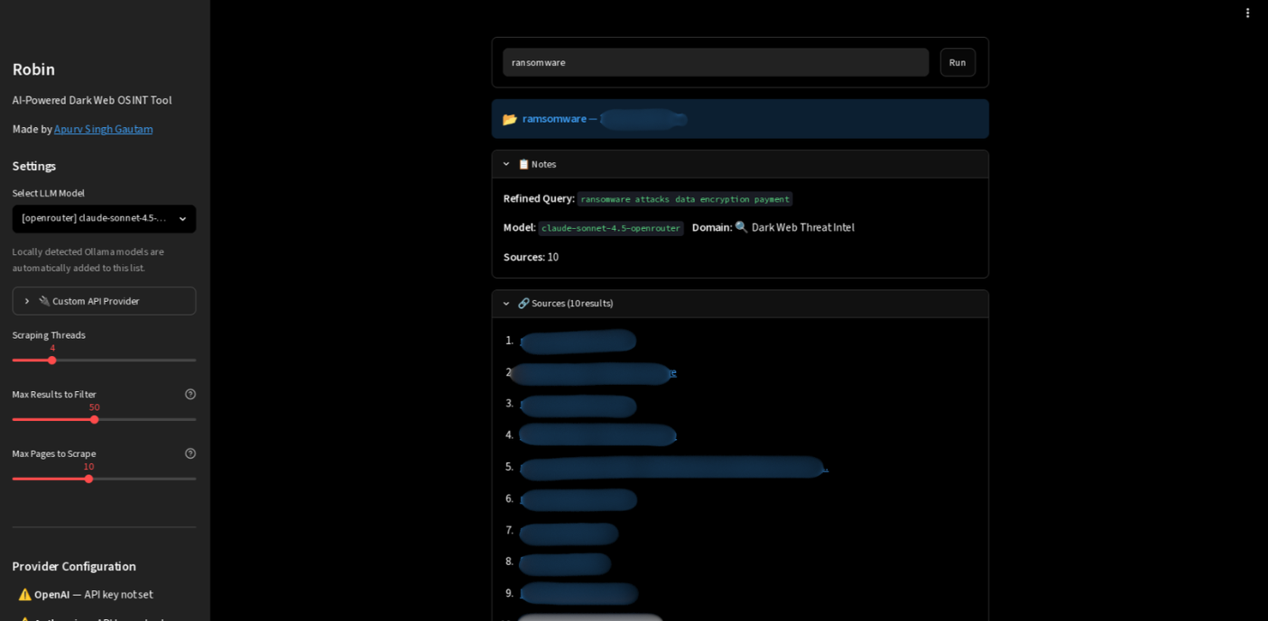
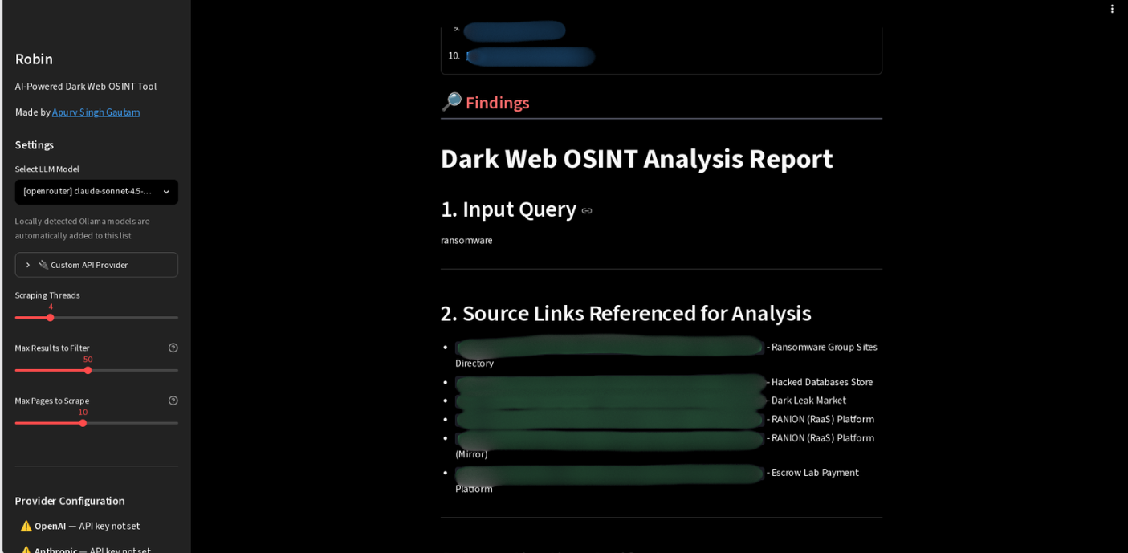
Setting up robin tool using python isn’t that complicated itself, on whonix I had to follow these steps:
- Make sure python is downloaded ( python3 as for today )
- Download additional packages like pip and venv
- Download git
- Using git clone https://github.com/apurvsinghgautam/robin.git command, download robin repo
- set up venv environment using python3 -m venv venv inside of Robin folder
- Activate using source venv/bin/activate
- Download packages from requirements.txt file using command pip install -r requirements.txt ( it will take a while )
- Set up the .evn file ( you need to create it and follow .evn.example file , if you don’t see the file in the folder, use ls -la command to show hidden files as well )
- Once ready, run streamlit run ui.py and follow one of two links generated to local page of robin ( IP address 10.152.152.11 is the default Whonix workstation IP )
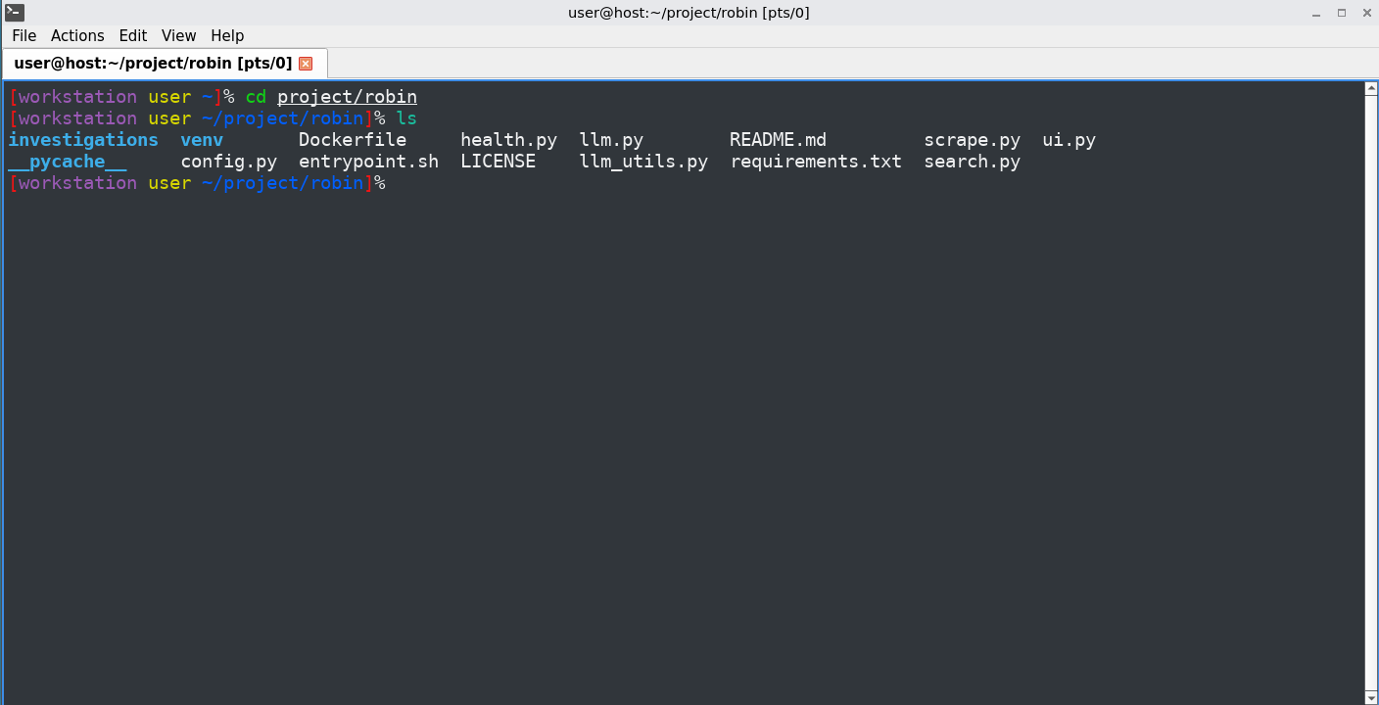
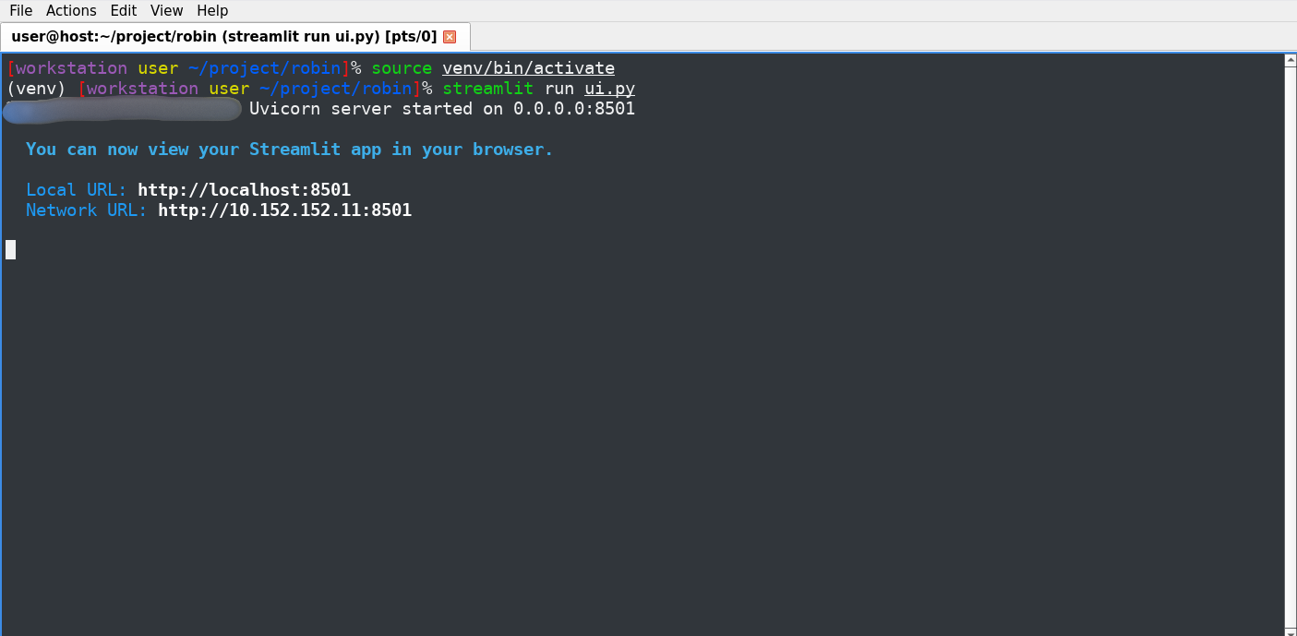

Summary of Research
After some testing and research as well as all of the above I came to the point of my project, where I think I can say with absolute certainty that it is possible to safely and efficiently use the dark web on a daily basis.
Using Robin with python + whonix environment + tor and any other additional safety measures like VPN will make it happen, giving you a safe place that protects you and even in the worst case scenario, will be able to contaminate the threat. All of that without too much loss on network load, Internet speed or unresponding interface that loads very long.
I would like to mention that the dark web, as for cybersecurity professionals, is a place that can help to identify problems before they become public, because if there is a flaw in your system, it will probably be discovered and published first on the dark web, before anything else. Plus knowledge is uncensored there, meaning you can find really interesting information that could potentially help your cause. After all, not everyone on the dark web are dangerous criminals and secret groups, but also normal people or even unseen heroes that try to make the Internet a better place.

Reference
- https://github.com/apurvsinghgautam/robin : Robin tool github
- tails.net : tails official website
- https://www.torproject.org/?noredirect=1 : tor official website
- whonix.org/wiki/VirtualBox : whonix on virtualbox
- https://attack.mitre.org/tactics/TA0004/ : privilege escalation
- https://www.docker.com : docker website
- https://docs.python.org/3/library/venv.html : python3 venv documentation
- https://apurvsinghgautam.me : Mr. Apurv Singh Gautam website

